Article title Comparative study of dental pulp stem cells derived from human permanent premolar and third molar teeth: characterization and osteogenic potential
Article author ¹, article author²
1Institute
2 institute
Abstract
Background: Abstract content

Objectives:

Materials and methods:

Results:

Conclusions:

Keywords:

Introduction
Implant placement with a proper three-dimensional position is an essential fundament for functional restoration and esthetic outcome. These are the key to achieve the clinical and long-term success of dental implants(Buser, Martin, & Belser, 2004).

Materials and methods
Patients who have edentulous space (at least 3 months post-extraction) and require two dental fixtures support a fixed partial prosthesis with including criteria as follows, adequate bone volume (including simultaneously implant placement with bone augmentation) and 20 years old and above were included in this study. The exclusion criteria were patients with uncontrolled systemic diseases or conditions that would affect osseointegration and / or healing process, limited mouth opening. All subjects (20 implants in 10 patients) were separated into 2 groups randomly with ratio of 1:1 using block randomization method: computer-guided surgery (n=10) and dynamic navigation system (n=10).

Implant planning process
The implant planning for both groups was performed by one operator. The DICOM files from CBCT were imported into the coDiagnostiX 9.7 software (Dental Wings inc, Montreal, CA) for computer-guided surgery group or IRIS-100 software (EPED Inc., Taiwan) for dynamic navigation group in order to create the virtual implant planning. For the guided surgery group, the STL file from the surface scan was imported and merged with DICOM image, the virtual implant planning, and the guide template was designed and sent to the laboratory for surgical guide production.
Implant placement
Only one surgeon with experience of implant placement performed all surgery. Straumann implants (Straumann, Basel, Switzerland) were placed under local anesthesia using the surgical guide template or dynamic navigation system machine. For guided surgery, each surgical template was position into patient mouth and stability was checked before the surgery started. In dynamic navigation, the registration process including patient registration and handpiece registration are the process to identify position and motion of the drill and to identify the fiducials marker in the surgical field to show the relationship between the fiducial marker from CBCT image and patient’s mouth.
Accuracy measurement
The parameters of measurement are including; deviation of the axis (degree), deviation of 3D offset at a platform(mm), deviation 3D offset at the apical of implant(mm). (Figure 1)
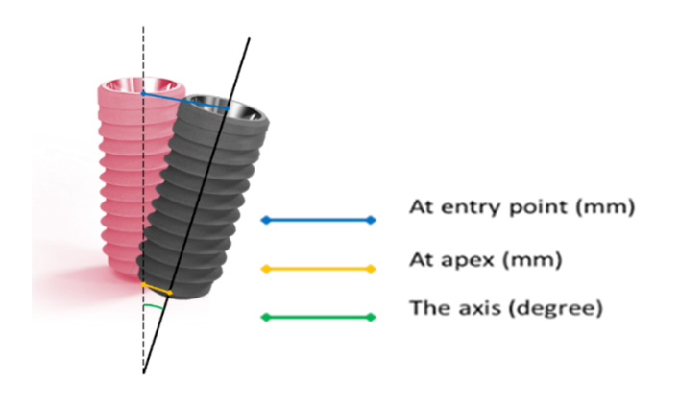
Figure 1 The parameters of measurement
Results
The average platform 3D deviations were 1.00±0.63 mm and 1.17±0.54 mm, while, the average apical 3D deviations were 1.35±0.91 mm and 1.24±0.53 mm and the average angular deviations were 2.66°±1.15° and 2.66°±1.09° for computer-guided surgery group and dynamic navigation group, respectively. (Table1and2)
Table 1 Deviation of implant position in the computer-guided surgery group.

Sample | Tooth | 3D Platform (mm) | 3D Apical (mm) | Angle (°)
G1 | 25 | 0.78 | 0.86 | 0.50
G2 | 26 | 0.65 | 0.63 | 1.50
G3 | 16 | 2.32 | 3.44 | 2.32
G4 | 17 | 1.84 | 2.4 | 1.84
G5 | 26 | 0.37 | 0.62 | 2.30
G6 | 27 | 0.34 | 0.87 | 3.30
G7 | 25 | 0.88 | 1.21 | 3.60
G8 | 26 | 0.59 | 0.73 | 3.90
G9 | 36 | 1.14 | 1.11 | 3.70
G10 | 37 | 1.14 | 1.68 | 3.70
 | Mean | 1.00 | 1.35 | 2.66
 | SD | 0.63 | 0.91 | 1.15
Table 2 Deviation of implant position in dynamic navigation group.
Sample | Tooth | 3D Platform (mm) | 3D Apical (mm) | Angle (°)
D1 | 36 | 0.96 | 0.90 | 2.03
D2 | 37 | 1.66 | 1.68 | 2.33
D3 | 45 | 0.96 | 1.06 | 3.39
D4 | 46 | 0.49 | 0.53 | 1.25
D5 | 36 | 2.11 | 2.31 | 2.83
D6 | 37 | 1.40 | 1.10 | 3.40
D7 | 35 | 0.85 | 1.03 | 1.28
D8 | 36 | 0.41 | 0.71 | 4.40
D9 | 45 | 1.14 | 1.59 | 3.91
D10 | 46 | 1.72 | 1.48 | 1.81
 | Mean | 1.17 | 1.24 | 2.66
 | SD | 0.54 | 0.53 | 1.09
The data from the study was non-normal distribution in all data sets, therefore Mann–Whitney U test was used for comparison. There was no significant difference in the implant precision found between computer-guided surgery and dynamic navigation system.
Discussions
The results of this study are similar to in vitro studies by Somogyi-Gnass et al(Somogyi-Ganss, Holmes, & Jokstad, 2015). No significant accuracy differences were found between using static and dynamic CAIS systems in the partially edentulous maxilla and mandible human cadaver in range of mean platform and apex deviation was less than 1.91 mm and 1.14 mm, respectively. The mean angular deviation was less than 4.24 degrees for both systems.
Taken together, it can be implied that computer-guided surgery and dynamic navigation system provide equal accurate and it can help clinicians to perform successful implant therapy.
Conclusions
This preliminary study demonstrated that using the computer-guided surgery and dynamic navigation system for implant placement provided similar accuracy of implant position. This result reflected accuracy can be achieved from both methods in patients needing two implants supported fixed partial denture. A surgeon can select either a guided or navigation system to provide proper implant position.

References
Buser, D., Martin, W., & Belser, U. C. (2004). Optimizing esthetics for implant restorations in the anterior maxilla: anatomic and surgical considerations. Int J Oral Maxillofac Implants, 19 Suppl, 43-61.
Cooper, L. F. (2016). Prosthodontic complications related to non‐optimal dental implant placement. Dental Implant Complications: Etiology, Prevention, and Treatment, 2, 539-558.
Ewers, R., Schicho, K., Undt, G., Wanschitz, F., Truppe, M., Seemann, R., & Wagner, A. (2005). Basic research and 12 years of clinical experience in computer-assisted navigation technology: a review. Int J Oral Maxillofac Surg, 34(1), 1-8. doi:10.1016/j.ijom.2004.03.018
Farley, N. E., Kennedy, K., McGlumphy, E. A., & Clelland, N. L. (2013). Split-mouth comparison of the accuracy of computer-generated and conventional surgical guides. Int J Oral Maxillofac Implants, 28(2), 563-572. doi:10.11607/jomi.3025

